CSA5103-Cryptography And Network Security
Experiment 5
Aim
To write a Python program to implement the Affine Caesar Cipher using the encryption formula:
$$C=\left(aP+b\right) 26$$
where:
- P = plaintext letter value
- C = ciphertext letter value
- a and b = encryption keys

Algorithm
- Start the program.
- Enter the plaintext.
- Enter the values of a and b.
- Check whether:
$$gcd\left(a , 26\right)=1$$
- If the condition is false, display “Invalid value of a”.
- Convert each plaintext letter into a number from 0–25.
- Apply the Affine Cipher formula:
$$C=\left(aP+b\right) 26$$
- Convert the resulting number back into an alphabet letter.
- Display the encrypted message.
- Stop the program.

Program:
# Affine Caesar Cipher
import math
plaintext = input("Enter the plaintext: ").upper()
a = int(input("Enter the value of a: "))
b = int(input("Enter the value of b: "))
# Check whether a is valid
if math.gcd(a, 26) != 1:
print("Invalid value of a")
print("a must be coprime with 26")
else:
ciphertext = ""
for char in plaintext:
if char.isalpha():
# Convert letter into number
p = ord(char) - ord('A')
# Apply Affine Cipher formula
c = (a * p + b) % 26
# Convert number into letter
ciphertext += chr(c + ord('A'))
else:
ciphertext += char
print("Encrypted Text:", ciphertext)

Output:
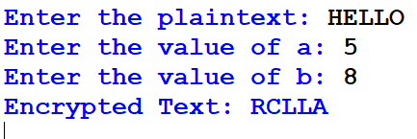

Result:
Thus, the Python program for the Affine Caesar Cipher was implemented successfully, and the plaintext was encrypted using the formula:
$$C=\left(aP+b\right) 26$$
The program also verified whether the value of a was valid.

